***Challenge 9***

Add post form

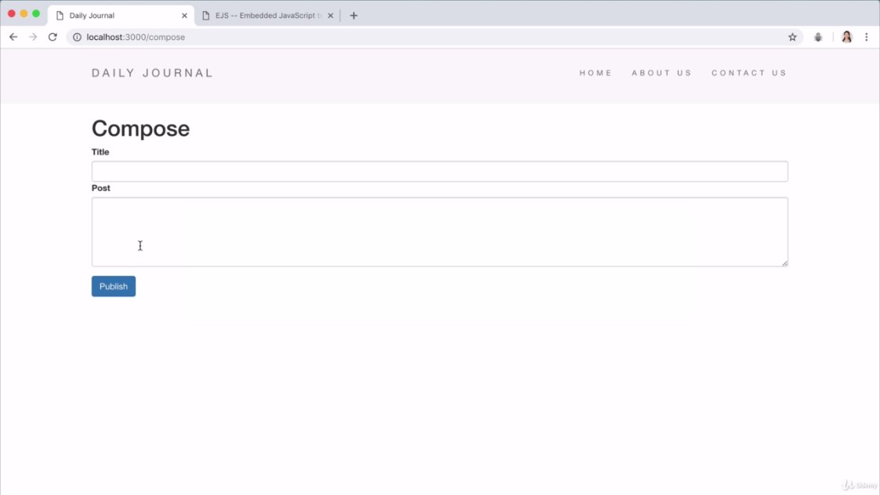

Search **multiline textbox html form** from google.

<https://stackoverflow.com/questions/6262472/multiple-lines-of-input-in-input-type-text>

<textarea name="Text1" cols="40" rows="5"></textarea>

Search bootstrap form

<https://getbootstrap.com/docs/4.3/components/forms/>

**compose.ejs:**

<%- include("partials/header") -%>

<h1>Compose</h1>

<form class="" action="/compose" method="post">

<div class="form-group">

<label>Title</label>

<input type="text" name="postTitle" class="form-control">

<label>Post</label>

<textarea name="postBody" cols="30" rows="5" class="form-control"></textarea>

</div>

<button type="submit" name="button" class="btn btn-primary" >Publish</button>

</form>

<%- include("partials/footer") -%>